### 

Software Requirement Specification

Văn Lang Admissions

# Revision Table

|  |  |  |  |
| --- | --- | --- | --- |
| Author | Date | Reason for changes | Version |
| Khoi Nguyen | 8/12/2016 | Initial the document | 1.0 |
| Khoi Nguyen , Hien Nguyen | 13/12/2016 | Update non-functional requirement , detail quality attribute scenarios , product scope.  Update operating environment , assumption. | 1.1 |
| Khoi Nguyen , Hien Nguyen | 20/12/2016 | Update Orther Non-Functional Requirements | 1.2 |

Table of Contents

Revision Table 1

1. INTRODUCTION 3

1.1. Purpose 3

1.2. Product scope 3

1.3. Definitions, acronyms and abbreviations 4

1.4. Audience 5

2. Overall description 5

2.1. Product perspective 5

2.2. Product functionality 6

2.3. Users and characteristics 6

2.4. Oerating environment 7

2.5. Design and implementation constraints 7

2.6. User documentation 8

2.7. Assumptions and dependencies 8

3. Specific requirements 8

3.1. External interface requirements 8

3.2. Functional requirements 9

3.3 Business rules 11

APPENDIX A: REFERENCES 12

# INTRODUCTION

## Purpose

This document provides a complete description of the features and requirements of the Web Văn Lang Admissions project. This document is used as commitment between customer and development team about output product and development process‘s rules.

This document provide for project team member:

* Used to support project team can understand the overview of the system.
* Used to support the design-oriented analysis and design system architecture and detail design.
* Used to support software testing to create test plan and acceptance test.

## Product scope

Văn Lang Admissions is web page introduce information and admissions news of Văn Lang University. At the same time allow the aptitude exam candidates can register online.

Based on customer requirements , BSS Team divide this system into three releases :

Release 1 : 4 module

* Manage News
* Manage Categories
* Manage Account
* Manage Resource

Release 2 : 3 module

* Manage Examination
* Manage Q/A
* Manage Homepage

Release 3 : 3 module

* Manage Pop-ups
* Manage Banners
* Change Languages

Some features may be included in the software but not required:

* View the admissions video
* Comment the admissions video

## Definitions, acronyms and abbreviations

This following table describes key terms and important acronyms in this project:

|  |  |  |
| --- | --- | --- |
| No. | Term | Definition |
| 1 | BSS | Base Steps Solution Team who develop this project |
| 2 | PM | Project Manager |
| 3 | UC | Usecase |
| 4 | SRS | Software Requirement Specification |
| 5 | UI | User Interface |

## Audience

|  |  |
| --- | --- |
| Intended Audience | Reading Suggestions |
| Project manager | Functional requirements, business constraints to estimate project. |
| Architect and designer | Use cases, constraints, quality attributes to architect and design the system. |
| Tester | Use cases to develop system test, integration test, test plan and acceptance test. |
| Customer | Use-case diagram, use-case description, quality Attribute. |

# Overall description

## Product perspective

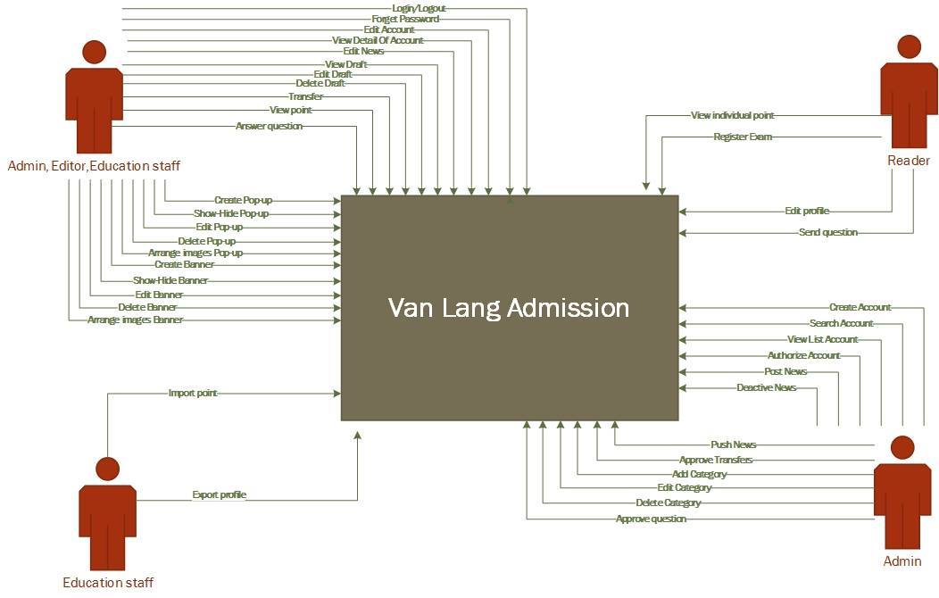

## Product functionality

|  |  |  |
| --- | --- | --- |
| Modul | Description | Priority |
| Manage Accounts | This module help user manages account of system | High |
| Manage News | This module help user manages all the news on website | High |
| Manage Categories | This module help user manages all Categories of website | High |
| Manage Examination | This module help user manages about issues related to examinations | High |
| Manage Q/A | This module help user manages Q/A | High |
| Manage Pop-ups | This module help user manages Pop-ups | High |
| Manage Banners | This module help user manages Banners | High |
| Change Languages | This module help user change languages | Medium |

## Users and characteristics

|  |  |  |
| --- | --- | --- |
| # | Role | Responsibility |
| 1 | Admin | Manage website, manage account & approve news |
| 2 | Editor | Post news about admission and answer question about admission. |
| 3 | Education staff | Manage examination, import point and answer question about education. |
| 4 | Reader | View news and point on website, ask questions, register examination |

## Oerating environment

User Computer:

* CPU: Intel Pentium 4 or higher.
* RAM: 1GB or higher.
* Resolution: 800x600
* Web browser:
  + Chrome
  + Firefox
  + Internet explorer
  + Cốc cốc

Server :

|  |  |  |  |  |
| --- | --- | --- | --- | --- |
| Item | Webserver (minimal) | Webserver (recommended) | Combined Web & Database Server (minimal) | Combined Web & Database Server (recommended) |
| Processor | 1,6 GHz CPU | 2x1,6 GHz CPU | 2x1,6 GHz CPU | 4x1,6 GHz CPU |
| RAM | 1,75 GB RAM | 3,5 GB RAM | 3,5 GB RAM | 7 GB RAM |
| HDD | 1x 300 GB of free space or more is recommended for the webshop data (non-system drive is preferred)  1x 300 GB of free space or more is recommended for the software that is listed in the software requirements (system drive) | | | |
| Operation System | Linux | | | |

## Design and implementation constraints

* Business constraint

BC1: Project is during 30 weeks.

Start date: 1/10/2016

End date: 30/4/2016

* Technical constraint

TC1: Database: mongodb, elasticsearch, redit

TC2: Development language: JavaScript

TC3: Framework: AngularJs

TC4: Platform: NodeJs

## User documentation

When our system is used, we will give documents:

* User guide
* Installation instructions

## Assumptions and dependencies

Assumption

* AS1: System has 3000 enroll each year.
* AS2: Response about 500 user access into system in 2 seconds , > 500 user response about 4-5s

Dependence

To be define.

# Specific requirements

## External interface requirements

Refer to BSS_UsecaseDescription_V1.0 document

## Functional requirements

|  |  |  |  |
| --- | --- | --- | --- |
|  | **Usecase ID** | **Function** | **Description** |
| Manage Accounts | UC-MA-01 | Log-in | Actors log in website |
| UC-MA-02 | Log-out | Actors log out website |
| UC-MA-03 | Create Account | S_Admin create new account for somebody |
| UC-MA-04 | Edit Account | Actors edit information of their account |
| UC-MA-05 | Search Account | S_Admin search account |
| UC-MA-06 | Forget Password | Actors forget password and find password |
| UC-MA-07 | View Detail Of Account | Actors view the detail of their account |
| UC-MA-08 | View List Account | S_Admin view list of accounts |
| UC-MA-09 | Authorize | S_Admin authorizes for account |
| UC-MA-10 | Deactive | S_Admin deactive account |
| Manage New | UC-MN-01 | View New | Actors view news in the website |
| UC-MN-02 | Post | Admin posts the news |
| UC-MN-03 | Edit | When the news is transferred and approved if the news have problem, actors will fix it. |
| UC-MN-04 | View Draft | Actors view draft of the news |
| UC-MN-05 | Edit Draft | Actors edit draft of the news |
| UC-MN-06 | Delete Draft | Actors delete draft of the news |
| UC-MN-07 | Transfer | Actors transfer the news to somebody |
| UC-MN-08 | Approve | C_Admin approve the post from someone transfers to him |
| UC-MN-09 | Deactive | C_Admin deactives the news |
| UC-MN-10 | Search | Actors search the news which they want to view |
| UC-MN-11 | Sort | Actors sort the new follow the alphabet, posted date. |
| UC-MN-12 | Push | C_Admin push the news to the top |
| Manage Categories | UC-MC-01 | View | Actors view the categories |
| UC-MC-02 | Add | C_Admin adds new category |
| UC-MC-03 | Edit | C_Admin edits the exist category |
| UC-MC-04 | Delete | C_Admin deletes the category |
| Manage Examination | UC-ME-01 | View point | Actors view list points of candidates |
| UC-ME-02 | View individual point | Users view point follow candidate code |
| UC-ME-03 | Register Exam | Users register skill examination |
| UC-ME-04 | Import point | Education staff import list of point into the system |
| UC-ME-05 | Export profile | Education staff exports profile of candidate |
| UC-ME-06 | Edit profile | Users edit profile |
| Manage Q/A | UC-MQA-01 | Send question | Users send the question |
| UC-MQA-02 | Answer question | Actors answer the question to reader and the answer will be send to admin |
| UC-MQA-03 | View question | Actors view the approved question |
| UC-MQA-04 | Approve question | If the question and the answer is good, admin will approve and post it |
| UC-MQA-05 | Search Question | Actors search the question which is posted |
| Manage Pop-ups | UC-PU-01 | Create | Actors create new pop-up |
| UC-PU-02 | View | Actors view the pop-up on website |
| UC-PU-03 | Show-Hide | Actors show or hide the pop-up |
| UC-PU-04 | Edit | Actors edit information of pop-up |
| UC-PU-05 | Delete | Actors delete pop-up |
| UC-PU-06 | Arrange images | Actors arrange images in pop-up |
| Manage Banners | UC-MB-01 | Create | Actors create new banner |
| UC-MB-02 | View | Actors view the banner on website |
| UC-MB-03 | Show-Hide | Actors show or hide the banner |
| UC-MB-04 | Edit | Actors edit information of banner |
| UC-MB-05 | Delete | Actors delete the banner |
| UC-MB-06 | Arrange images | Actors arrange images in banner |
| Change Languages | UC-CLG-01 |  | Actors change language |
| Manage Homepage | UC-MH-01 | Add | Actors add field to show on homepage |
| UC-MH-02 | Edit | Actors edit field |
| UC-MH-03 | Delete | Actors delete field |

## 3.3 Business rules

|  |  |
| --- | --- |
| ID | Description |
|  |  |
|  |  |

1. ORTHER NON-FUNCTIONAL REQUIREMENTS

|  |  |  |  |
| --- | --- | --- | --- |
| Id | Quality Attribute | Description | Priority |
| SQA-P01 | Performance | When users use the system to view the necessary information, the system will respond quickly, display results in 2 seconds | High |
| SQA-P02 | Education staffs can import point into system average 1000 points will import about 4 seconds | High |
| SQA-A01 | Availability | When Web server unresponsive, can re-operation quickly | High |
| SQA-C01 | Scalability | System can expand limit number of users | High |
| SQA-U01 | Usability | System has friendly interface and easy to use | Medium |
| SQA-R01 | Portability | Users can use the system on mobile platform | Medium |
| SQA-M01 | Modifiability | The system can add/delete/modify other functions later | Medium |
| SQA-S01 | Security | System can authorize user’s information | Low |

Detail quality attribute scenarios : BSS_QualityScenario_V1.1.docx

1. ORTHER REQUIREMENTS

# APPENDIX A: REFERENCES